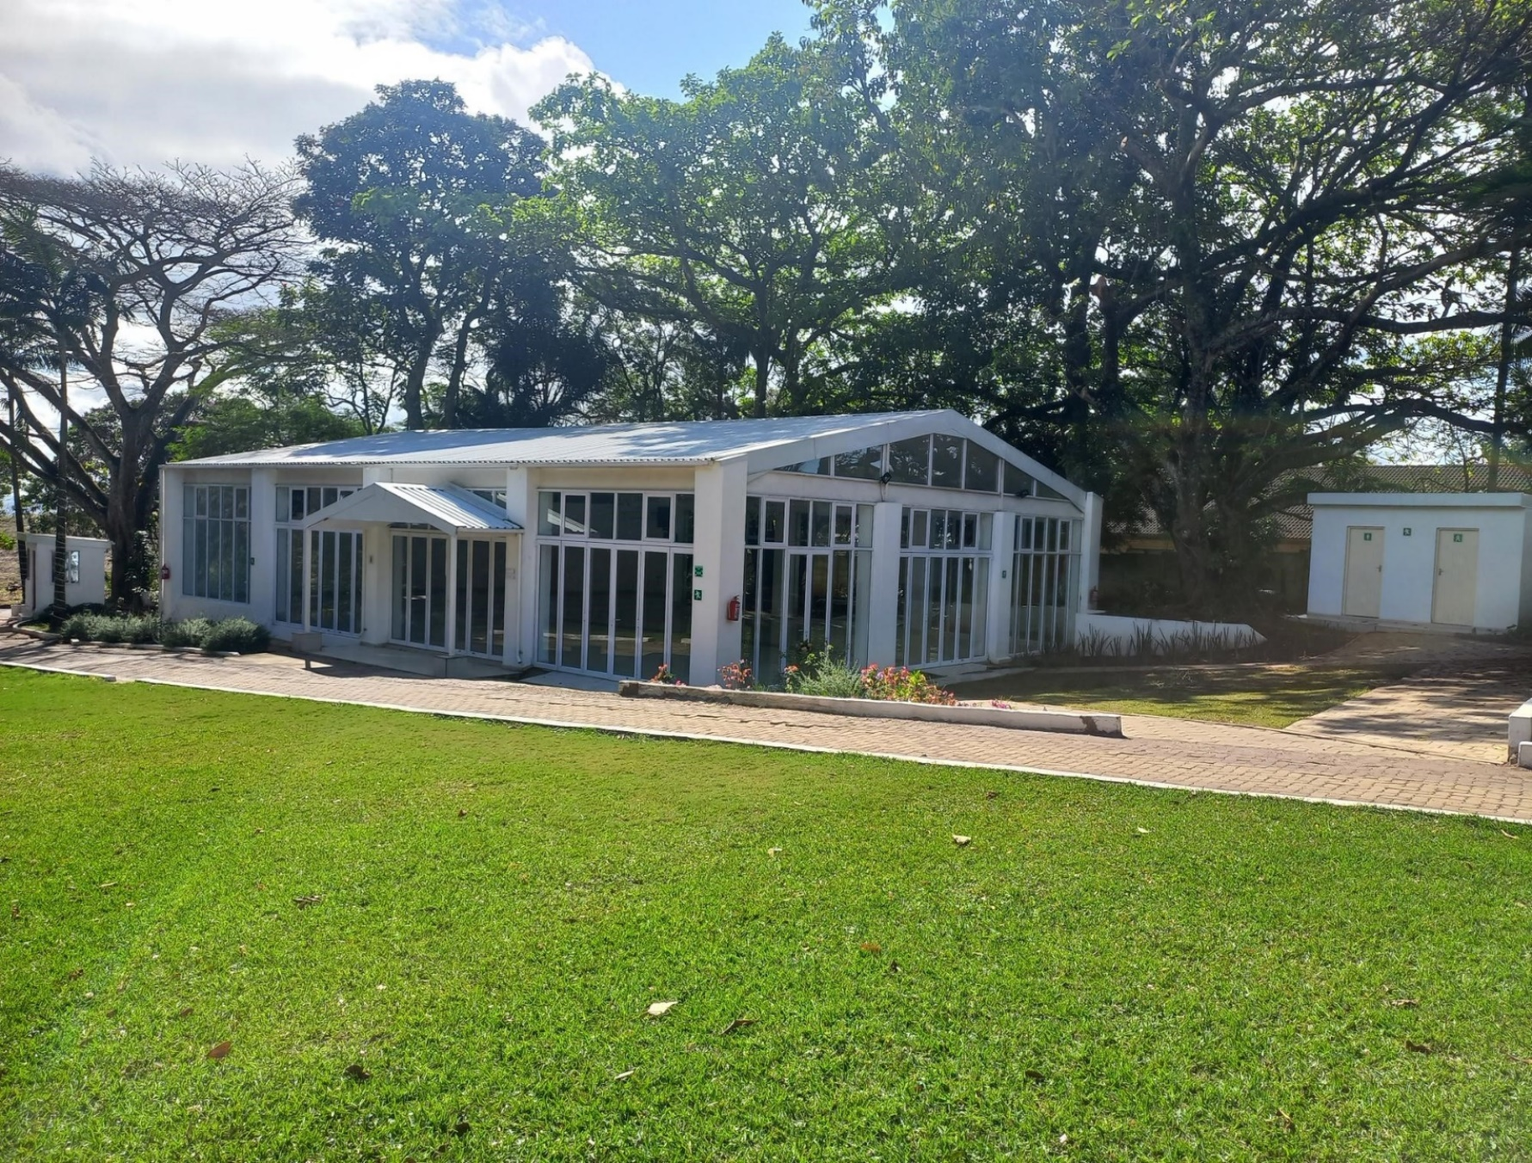

|  |
| --- |
|  |
|  |
| December 23BUSINESS PROFILE  Ulifa Lodge & Wedding Venue  Ulifa Investments (Pty) Ltd  Reg No. 2008/035 473 2096  Vat Reg: 477 029 4389  Phone: 035 473 2008/035 473 2096  Email: ulifalodge@gmail.com |

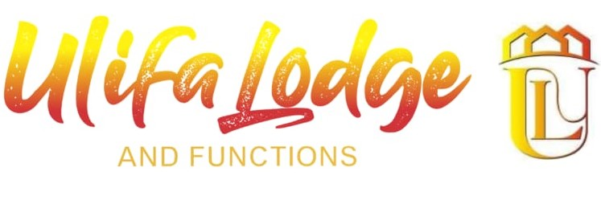

# CONTENTS

|  |
| --- |
| Introduction of Ulifa Lodge & Wedding Venue  1. Goal & Vision 2. Services Provided 3. Facilities 4. Contact Details 5. INTRODUCTION OF ULIFA LODGE & WEDDING VENUE   ULIFA INVESTMENT PTY LTD t/s Ulifa Lodge & Wedding venue is a 3-Star Lodge and wedding venue located in Westville (Durban) under Ethekwini municipality.  The Lodge was founded & Established by Dumisani Madi in 2019 the main purpose of the company is lodging guests from all over South Africa.  The lodge also has venue to cater for conferences with a capacity of |

+30 People. The venue also has a sanctuary garden for outdoor events such as Picnic or Garden wedding.

1. GOAL & VISION

We strive to provide exceptional experiences for our guests, while providing an excellent work environment for our staff and obtaining industry leading results in hospitality.

Uplifting the township around westville and create more job opportunities whilst playing a role in the hospitality business sector as well.

1. SERVICES PROVIDED

* Accommodation
* Function Venue (Conferences, Parties, closing functions etc.)
* Braai Facilities
* Out Door Garden
* Private swimming pool

1. FACILITIES

|  |  |  |
| --- | --- | --- |
| Reception Area | Dining Hall & Coffee Shop | Conference Hall |
|  |  |  |

|  |  |  |
| --- | --- | --- |
| Accommodation (Rooms) | | |
|  |  |  |

1. CONTACT DETAILS

Reservations, Booking enquiries

Phone: 031 267 7080/064 526 5520

Email: guesthouse@ulifalodge.co.za